Service-Oriented Architecture (SOA) – Simplified Points
Basic Meaning
- SOA is a software development method that builds applications using independent components called services.
- Each service performs a specific business capability.
- Services can communicate with each other even if they use different platforms or programming languages.
- SOA is both a specification and a methodology for building distributed, platform-independent services.
How Services Work
- A service is a repeatable task within a business process.
- A business task is formed by combining multiple services.
- SOA uses message passing between components to provide services when requested.
- Clients send a message (with metadata) in a standard format to access a service.
- The service processes the message and returns a response.
- A common example of a message format is XML sent using SOAP.
Architecture Characteristics
- There are no direct API links; only messages are exchanged.
- The client checks whether the returned result is appropriate.
- SOA is viewed as linking several services to form an integrated business process.
- A component that provides a service is exposed as an “endpoint.”
Common Message Formats and Languages
- XML + SOAP is most commonly used.
- Other formats include WSDL, WSS, and WS-BPEL.
- WSDL describes the service interface, binding details, and the nature of the service/endpoint.
- SCDL defines the internal service component details not included in WSDL.
Role of Middleware
- Service providers and consumers usually do not communicate directly.
- Middleware acts as a transaction manager and translator.
- Middleware can discover and list available services through a registry.
- Security and trust services are built into middleware.
- Business logic can also reside inside middleware.
- UDDI protocol is commonly used for broadcasting and discovering Web services, often using ebXML documents.
- Service consumers locate a service in the registry and bind their requests to it.
Core SOA Values
- Business value
- Strategic goals
- Intrinsic interoperability
- Shared services
- Flexibility
- Evolutionary refinement
SOA Protocol Stack
- SOA uses multiple protocols that handle different required functions.
- Other supported service technologies include CORBA, REST, RPC, DCOM, Jini, DDS, WCF, etc.
- SOA is flexible and neutral, making it useful for designing complex applications.
- The message provides data, the service responds, and the client verifies correctness.
- The formal definition of a transaction in SOA is called a “contract.”
- SOA uses an orchestrator or broker to ensure correct message transactions.
- SOA focuses only on the interaction boundary between the client (consumer) and the service provider.
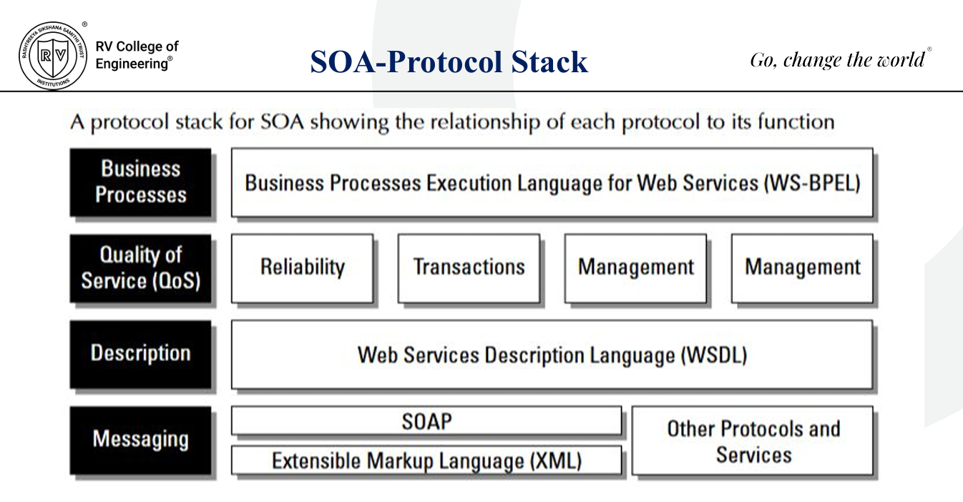

SOA – Choreography
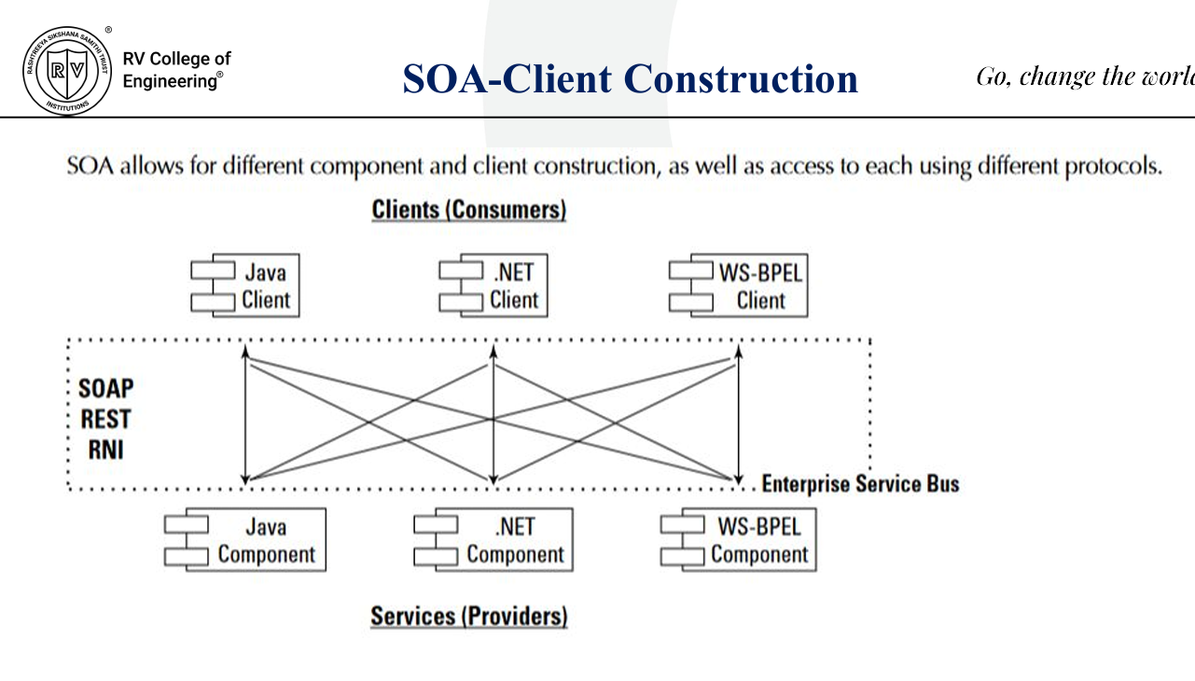
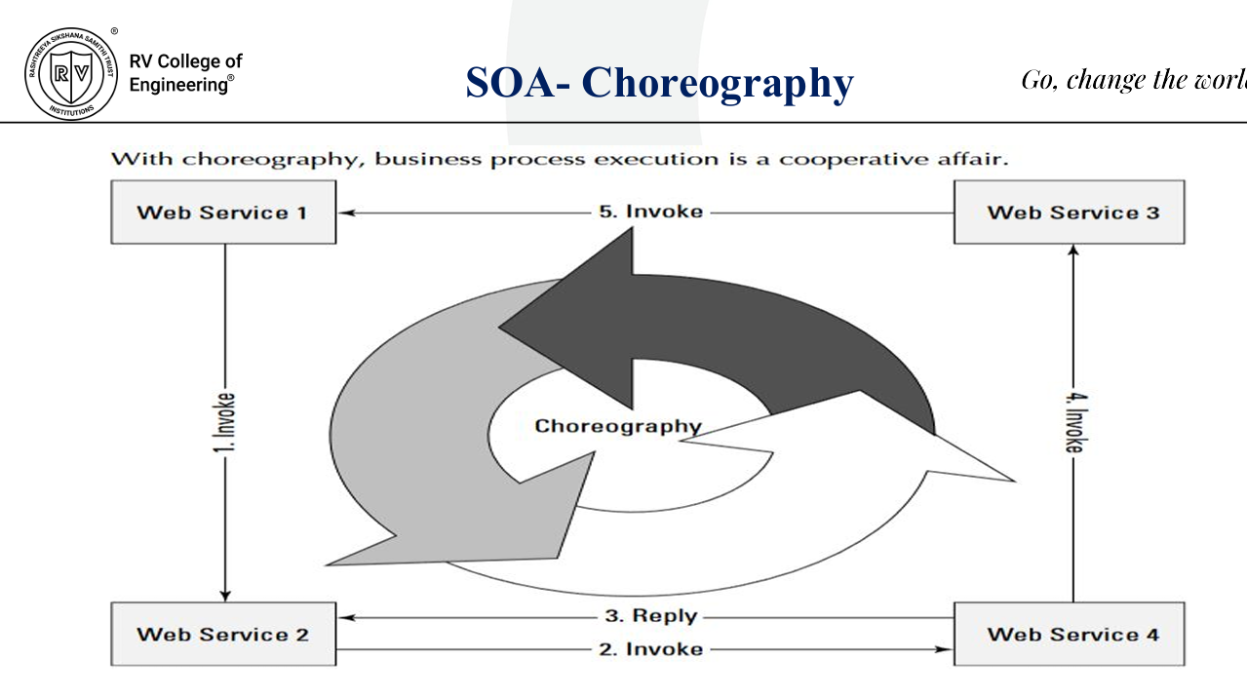
- Components of different types can communicate using different protocols in SOA.
- When Web services are combined to form business processes, the integration must be managed.
- Two methods are used to combine Web services: orchestration and choreography.
- In orchestration, a middleware service centrally coordinates all Web service operations.
- All services send and receive messages through this central orchestrator.
- In choreography, there is no central controller.
- Each Web service knows:
  - When to process a message
  - Which client or component to interact with
- Choreography is collaborative; each service handles:
  - Which operations to run and when
  - How messages are structured
  - Message timing and related decisions

Orchestration
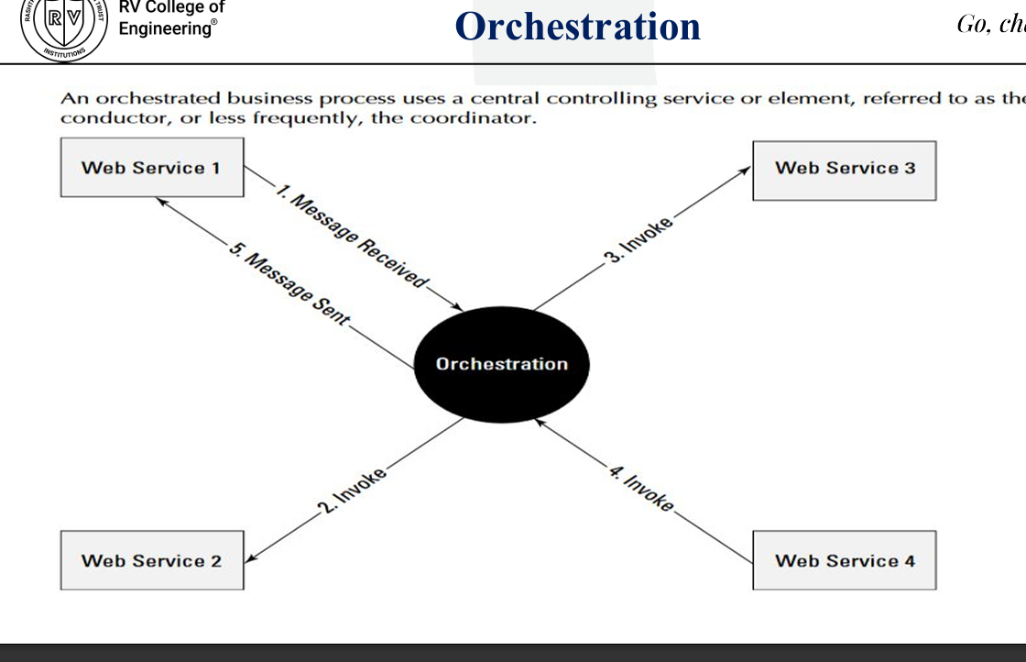
SOA – Choreography (continued)
- Most mature SOA implementations prefer orchestration over choreography.
- Orchestration has a single central service that manages all processes, making updates easier.
- Integrating Web services becomes simpler because services do not need knowledge of the business process.
- Centralizing business logic makes error handling easier.
- It also helps in managing and analyzing events that occur outside the business process.
- Event handling is part of event-driven SOA (SOA 2.0), which includes both random and scheduled events triggered inside or outside the business process.
- One method of implementing orchestration is through an Enterprise Service Bus (ESB).
- An ESB provides a middleware layer for event management with a messaging infrastructure.

Event-driven SOA or SOA 2.0
- Event-driven SOA (SOA 2.0) extends traditional SOA to respond to events that occur during business processes or influence those processes.
- Example: If a system detects a rapid increase in sales on a website, it can analyze what events might be influencing customer buying decisions.
- SOA 2.0 handles such analysis by allowing:
  - Low-level events to trigger a business process
  - Events to be correlated with SOA data
  - A business process to stop if expected events do not occur
  - Automatic reactions or responses based on event triggers
- To support this, a Causal Vector Engine (CVE) with built-in artificial intelligence is added to the SOA design.
- Events are analyzed based on:
  - Event sequences
  - Event relationships
  - Event timing
- The CVE reacts to conditions using predefined rules.
- CVE systems often display events in different contexts on a console for observers to analyze and take action.

Event-driven SOA or SOA 2.0 (continued)
- CVE applications may allow querying event data, similar to how stock trading systems query trading data.
- CVE provides heartbeat and correlation functions similar to stock market applications.
- For the client (service consumer):
  - They only need to know how to call the service and interpret the returned results.
  - They do not know how the component processes the request, where it runs, or which systems are involved.
- The client must validate whether the returned result meets expectations.
- The SOA component behaves as a black box to the client.
- SOA requires only that components follow standard endpoint rules.

Event-driven SOA or SOA 2.0 (continued)
- This abstraction allows service providers to upgrade, replace, or relocate components without affecting clients.
- Quality of Service (QoS) can still be measured and maintained.
- SOA provides rules that let applications access authentication modules in their own way.
- Benefits of SOA:
  - Adds powerful capabilities with much less cost and effort
  - Allows applications to be federated if needed
- Limitation of SOA:
  - You cannot deeply customize a service if it is provided by a third party
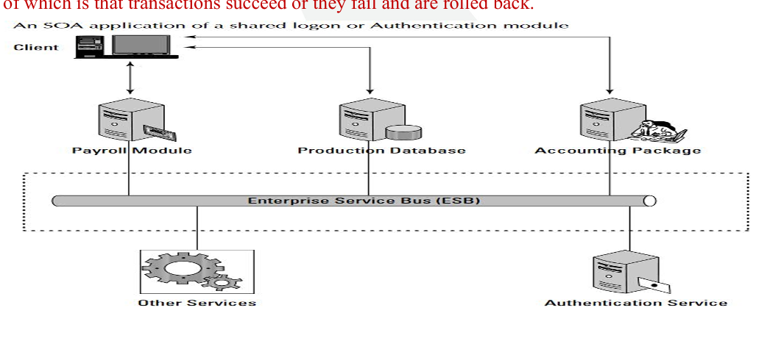
The Enterprise Service Bus
- An ESB is not a physical network bus; it is an architectural pattern made of network services that manage transactions in SOA.
- It separates clients from components on a transactional basis, giving the system a loosely coupled structure.
- Messages flow from client to component through the ESB, which manages the transaction regardless of where the services are located.
- An ESB is useful but not mandatory in SOA because business processes may involve many messages and events, and distributed processing can be unreliable.
- The ESB acts as a transaction broker, ensuring messages reach their correct destination and are handled properly.

The Enterprise Service Bus
- The ESB performs mediation functions such as:
  - Message translation
  - Registration
  - Routing
  - Logging
  - Auditing
  - Maintaining transactional integrity
- Transactional integrity is similar to ACID in databases—transactions must either fully succeed or fail and roll back.

The Enterprise Service Bus
- An ESB can be part of a network operating system or implemented using middleware products.
- It creates a virtual environment on top of an enterprise messaging system where services are advertised and accessed.
- An ESB is essentially a message transaction system.
- Example: IBM WebSphere ESB 7.0 uses open standards such as Java EE, EJB, WS-Addressing, WS-Policy, and Kerberos.
- It runs on WebSphere Application Server and is compatible with Open SCA.
- It includes a Service Federation Management tool and an integrated Registry and Repository.

The Enterprise Service Bus
Typical features found in ESBs include:
- Monitoring services for managing events.
- Process management services to manage message transactions.
- Data repositories or registries to store business logic and support governance.
- Data services to pass messages between clients and services.
- Data abstraction services to translate message formats as needed.
- Governance services to ensure compliance with government regulations.
- Security services to validate clients and services and allow secure message exchange.

The Enterprise Service Bus
- A repository and a registry are both data stores but serve different roles in SOA.
- A repository stores references to SOA components, their source code, and linking information used to provide services.
- A registry stores the rules, descriptions, and definitions of services—i.e., the metadata.
- A repository is similar to a name server, while a registry functions like a directory service (domain).
- The service broker uses rules in the registry to translate and deliver messages.
- The registry is the central location where developers store component descriptions and publish services.
- SOA services also include provider interfaces and standard network protocols.
- Developers may create a Business Process Orchestration module to coordinate access and maintain transactional integrity across multiple business applications.

Service Catalogs
- In a large SOA system, finding a specific service and its requirements can create heavy network overhead.
- To simplify this, SOA often includes a catalog service.
- A catalog service stores information such as:
  - What services are available (internal and external)
  - How to use each service
  - Which applications depend on a particular service
  - How services are related to one another
  - Who owns the service and how it can be modified
  - The event history of a service (service levels, outages, etc.)
  - The nature of service contracts

Service Catalogs
- Service catalogs are dynamic and constantly updated.
- Catalog servers may have the following forms:
  - A standalone catalog server for a single site
  - A global catalog service created by merging multiple catalog servers across sites
(requires synchronization to keep data unified)
  - A federated catalog service, where multiple global catalog servers share information through a trusted query relationship
- Catalog services significantly affect performance in large systems.
- As a SOA internetwork grows, catalog services become essential.
- An internetwork is created by combining multiple separate networks, similar to how the Internet was formed.

SOA Communications
- Message passing in SOA uses two protocol types:
  - A data interchange format
  - A network protocol that carries the message
- A client connected to an ESB communicates using protocols like HTTP, REST, or JMS.
- Messages are usually formatted in XML or SOAP.
- SOAP uses XML for messages and relies on protocols like HTTP and RPC for sending and negotiating messages.
- Clients and services can be written in Java, .NET, WS-BPEL, or other programming languages.
- The key requirement is the ability to transport and translate messages so both sides understand them.

SOA Communications
- An ESB may support multiple protocol and format combinations.
- Examples from WebSphere ESB include:
  - XML/JMS
  - SOAP/JMS
  - SOAP/HTTP
  - Text/JMS
  - Bytes/JMS
- WSDL is a widely used XML protocol for messaging in Web services and SOA.

SOA Communications
- WSDL 1.1 is a W3C standard; WSDL 2.0 is newer but not yet ratified.
- WSDL 2.0 has better support for RESTful applications, but tool support is still limited.
- The most common transport for WSDL is SOAP.
- WSDL files contain XML data and an XML schema.
- REST provides different capabilities than SOAP:
  - Each URL represents an object you can access or modify.
  - Uses standard HTTP commands: GET, POST, PUT, DELETE.
- SOAP exposes Web objects through an API and transfers data using XML.
- REST is lightweight, easier to implement, and has less overhead than SOAP.

SOA Communications
- SOAP offers more precision and a more error-free consumption model, along with advanced development tools.
- Most major Web services use REST, but many also combine REST and SOAP for combined benefits.
WSDL key objects for message transfer:
- Service object – container where the service resides.
- Port (endpoint) – the unique address of the service.
- Binding – defines the interface (e.g., RPC) and transport (e.g., SOAP).
- PortType – defines what the Web service can do, including operations and required messages.
- Operation – the action performed on the message.
- Message content – the data and metadata the operation works on (may have multiple parts, each with type info).
- Types – data definitions, usually in the XML schema included in the WSDL.

SOA Communications
- The XML document in WSDL sets up the namespace, defines the interface, specifies the binding, names the service, adds documentation, and provides a schema for validation.
- Message types are declared in the message descriptions.
- XML schema may be in separate files but is often included inline in WSDL.
- A WSDL file contains message data for a transaction but does not capture the full SOA design.
- Additional requirements are expressed through a service contract.
- A service contract defines:
  - The data to be processed
  - The metadata
  - The intended service
  - How the service will act on the message

SOA Communications
- Header: Includes service name, version, owner, and responsibilities (often defined using a RACI matrix).
- Service Type: Examples include data, business, integration, presentation, and process services.
- Functional Specification: Defines functional requirements, operations, methods, invocation details, URL, and interface nature.
- Transaction Attributes: Describe how a transaction is managed, tracked, QoS level, SLA requirements, and security parameters.
- These attributes also specify the message's role in a process and the semantics of interaction.

Business Process Execution Language (BPEL) – 10-Point Summary
- BPEL handles groups of atomic transactions to execute complete business processes.
- It is a standard Web service execution language maintained by OASIS.
- BPEL is a meta-language containing executable commands and abstract business logic.
- It is used to compose, orchestrate, and coordinate business processes in SOA.
- BPEL supports asynchronous communication between services.
- It uses XML and works with SOAP, WSDL, UDDI, WS-ReliableMessaging, WS-Addressing, WS-Coordination, and WS-Transactions.
- BPEL combines IBM’s WSFL and Microsoft’s XLANG concepts, forming BPEL4WS.
- BPEL4People extends BPEL to support human interaction tasks.
- Business processes in BPEL have both internal (executable) and external (abstract) views.
- BPEL provides control flow, logic, branching, process orchestration, and error handling for long-lived, asynchronous transactions.

Business Process Modeling – Concise Summary
Unified Modeling Language (UML)
- UML (by OMG) provides graphical diagrams to model software systems.
- Includes actors, business processes, components, routines, database schemas, and activities.
- Consists of 7 structural and 4 behavioral diagram types.
- Widely used in industry and can be reduced to executable code.
- UML uses XMI (XML Metadata Interchange) to exchange metadata in XML.
XMI and SysML
- XMI is an OMG and ISO standard for exchanging metadata; files are not always interchangeable across tools.
- SysML is an open-source, simplified extension of UML supporting 7 of UML 2.0’s diagrams.
- SysML uses XMI and is developing support for ISO 10303 STEP AP-233.
Business Process Modeling Notation (BPMN)
- BPMN represents business processes through visual workflow diagrams (BPD).
- Created by BPMI, now part of OMG.
- BPMN diagrams can be converted into WS-BPEL for execution by Web services.

Service-Oriented Modeling Framework (SOMF)
- SOMF models SOA components visually as objects and relationships.
- Helps plan, optimize, trace message paths, and test “what-if” scenarios.
- SOMA (related approach) breaks systems into:
  - Services
  - Service components
  - Information flows
- Identifies domains, functional groups, process variables, and service granularity.
SOMF Service Life Cycle Stages
- Conceptualization – define supported processes
- Discovery – determine how components are exposed
- Analysis – identify service–client relationships
- Integration – implement messaging infrastructure
- Logical design – build system logic, orchestration/choreography
- Architecture design – design components and interfaces
- System implementation – build and test components

SOMF Message-Passing Topologies
- Circular topology:
  - No orchestrator; components decide what message to process and where to send next (choreography-based).
- Hierarchical topology:
  - Services arranged in parent–child tree; messages travel up and down branches.
  - Clear structure but less optimized message passing.
- Network topology:
  - Many-to-many communication; very fast message passing but requires many connections.
- Star topology:
  - Central hub service; ideal for orchestration, broadcasting, and publish/subscribe systems.

Service Types in SOMF
- Atomic service:
  - Smallest usable unit; cannot be decomposed.
  - Example: customer lookup (ID, name, address).
- Composite service:
  - Collection of related services (e.g., bank account or ESB functions).
  - Often hierarchical and coarse-grained.
- Service cluster:
  - Group of composite and/or atomic services forming a larger process module (e.g., payroll module).
How SOMF Models Services
- Services have distinct shapes and can be:
  - Aggregated
  - Decomposed
  - Unified
  - Intersected
  - Subtracted
- Connections show relationships such as generalization or specialization.
- Final model is optimized and mapped to system implementation; some tools generate executable code.

Managing and Monitoring SOA – Concise Summary
- Monitoring and managing SOA is critical in large deployments because SOA complexity requires proactive oversight, not reactive troubleshooting.
- SOA management tools run continuously and are multifaceted, handling monitoring, mapping, configuration, and optimization.
Major SOA Management Tools
- HP OpenView SOA Manager – provides dynamic mapping, monitoring, and optimization of Web services, software assets, and virtual services.
- IBM Tivoli ITCAM – focuses on change management, SOA lifecycle management, and integrates with WebSphere and other Tivoli systems.
- Oracle BPEL Process Manager – manages BPEL workflows and supports ESB creation.
Industry Trends & Additional Tools
- SOA management tools evolve rapidly; many small vendors’ products are acquired and merged into larger suites (e.g., Oracle acquiring AmberPoint).
- BMC AppSight and Tidal Intersperse provide automated problem resolution and root-cause analysis.
- CA Wily SOA Solution maps SOA transactions, dependencies, ESBs, portals, and Web services.
- iTKO LISA specializes in testing Web service components.
- OpTier CoreFirst is another SOA transaction manager.
Challenges in SOA Management
- SOA infrastructures are highly distributed, requiring strong discovery mechanisms.
- They are also highly virtualized, with workloads moving across virtual and physical servers dynamically.
- This constant shifting increases complexity, making configuration and change management difficult.
- Virtualization will remain a major challenge for SOA management tools in the future.

SOA Security – Concise Summary
- SOA sends large volumes of messages across networks, making it vulnerable to traditional attacks like hijacking, spoofing, redirection, and blocking.
- Because SOA removes traditional application boundaries, application-level security alone is insufficient.
- Cisco’s Application Oriented Networking (AON) and Citrix’s NetScaler provide policy-based XML message security.
OASIS Security Standards for SOA
1. SAML (Security Assertion Markup Language)
- XML-based standard for authentication and authorization between client and service.
- Used in Single Sign-On (SSO) to allow users to access distributed SOA resources after one login.
2. WS-Security (WSS)
- Adds security tokens (Kerberos, SAML, X.509) to messages.
- Uses XML Signature and XML Encryption for secure client/service communication.
3. WS-SecureConversation
- Creates and shares a security context for ongoing communication.
- Works with WS-Security, WS-Trust, and WS-Policy to attach security context tokens to SOAP messages.
4. WS-SecurityPolicy
- Defines policies requiring messages to be signed and encrypted.
- Extends WS-Security, WS-Trust, and WS-SecureConversation.
5. WS-Trust
- Extends WS-Security to issue, renew, and validate security tokens.
- Uses a Security Token Service (STS) for token generation and key exchange.

XML Gateways & PKI in SOA Security
- XML gateways inspect SOAP/REST XML messages, verify their source, and ensure secure delivery.
- Requires Public Key Infrastructure (PKI) to enforce encryption and digital signatures.
SOA Security Tools
- Progress Software’s Actional 8.0 (includes Mindreef SOAPscope) provides XML middleware for:
  - Diagnostic testing
  - Web service governance
  - Monitoring XML appliances and application servers

The Open Cloud Consortium (OCC) – Concise Summary
- The Open Cloud Consortium (OCC) is a group of universities and companies that develops cloud computing standards and supports interoperability between different cloud frameworks.
Key Functions of OCC Working Groups
- Develop benchmarks for cloud performance measurement.
  - Their benchmark for large data clouds is MalStone, with a data generator called malgen.
- Provide testbeds for vendors to test cloud applications, including:
  - The Open Cloud Testbed
  - The Intercloud Testbed
- Support creation of open-source reference implementations for cloud computing.
- Extend architectures for large data clouds through:
  - Distributed file systems
  - Table services
  - MapReduce-based computing (similar to Google’s model)
Related Technologies
- MapReduce is Google’s framework for processing large distributed datasets using the Google File System (GFS).
- Apache Hadoop is an open-source implementation inspired by MapReduce and GFS.
Additional OCC Initiatives
- Manage cloud infrastructure for scientific research through the Open Science Data Cloud (OSDCP) Working Group.

Relating SOA and Cloud Computing – Concise Summary
- Cloud computing is still developing, and while Web services can use SOA, it is not required for cloud applications.
- Many early cloud applications do not need the flexibility and loose coupling that SOA provides.
- As cloud applications grow in diversity and complexity, SOA becomes useful as a standardized, loosely coupled architectural blueprint for accessing different optimized services.
- SOA is loosely coupled because services are independent from the messaging system, making components easy to replace with minimal or no programming.
- Developers may lose some customization options, but gain easier application design and maintenance.
- Although SOA-based applications may seem tightly integrated, the underlying architecture remains loosely coupled.

